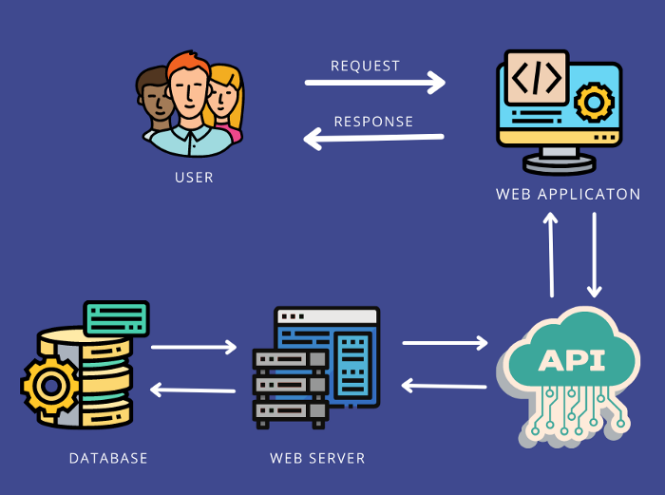

A RESTful API is a set of rules that defines how two computer systems can securely exchange information over the internet. It's a way for different applications to communicate with each other, often involving data exchange and other operations. RESTful APIs are based on the principles of Representational State Transfer (REST), an architectural style that emphasizes statelessness, client-server architecture, and a uniform interface.

Here's a more detailed explanation:

Key Concepts:

* **REST (Representational State Transfer):**

A set of architectural principles that define how web services should be designed for maximum flexibility and scalability.

* **API (Application Programming Interface):**

A set of rules and specifications that allow different software systems to communicate with each other.

* **Client-Server Architecture:**

RESTful APIs follow a client-server model, where the client (e.g., a web browser or mobile app) requests resources from the server.

* **Statelessness:**

In a RESTful API, each request from the client to the server must contain all the information needed to understand and process the request. The server doesn't store any client context between requests.

* **Uniform Interface:**

RESTful APIs use a standard set of HTTP methods (GET, POST, PUT, DELETE) to interact with resources. These methods define the type of operation to be performed on a resource.

* **Resources:**

RESTful APIs expose resources, which can be anything that can be identified by a URL (e.g., a user profile, a product, a list of orders).

How it works:

1. **1. Client Request:**

A client sends an HTTP request to a specific URL (endpoint) on the server, specifying the desired operation using an HTTP method (e.g., GET to retrieve data, POST to create data).

1. **2. Server Processing:**

The server receives the request, processes it, and retrieves or manipulates the requested resource.

1. **3. Server Response:**

The server sends back an HTTP response, which may include the requested data, a status code indicating success or failure, and other relevant information.

Example:

Imagine you're using a weather app. When you enter a city name, the app sends a RESTful API request to a weather service. The request might look like this: GET /weather?city=London. The weather service then processes the request, retrieves the weather data for London, and sends it back to the app in a JSON format. The app then displays the weather information to you.

Benefits of RESTful APIs:

* **Simplicity:**

RESTful APIs are relatively easy to understand and implement, making them a popular choice for web service development.

* **Scalability:**

RESTful APIs can handle large amounts of traffic and data because they are stateless and can be easily scaled horizontally.

* **Flexibility:**

RESTful APIs can be used with various programming languages and data formats, providing flexibility in development.

* **Loose Coupling:**

Clients and servers can evolve independently, making it easier to update and maintain the application.

* **Interoperability:**

RESTful APIs facilitate communication between different applications and systems, enabling integration and data exchange.

In RESTful APIs, HTTP methods define the actions performed on resources. They are crucial for creating, reading, updating, and deleting data (CRUD operations). The most common HTTP methods in REST are GET, POST, PUT, and DELETE.

Here's a breakdown:

* **GET:** Retrieves data from a specified resource.
* **POST:** Creates a new resource.
* **PUT:** Updates an existing resource, replacing it entirely.
* **DELETE:** Removes a resource.

These methods, when combined with a resource's URL (Uniform Resource Locator), allow clients to interact with and manipulate data on a server. They are fundamental to how RESTful APIs operate and enable communication between different applications.